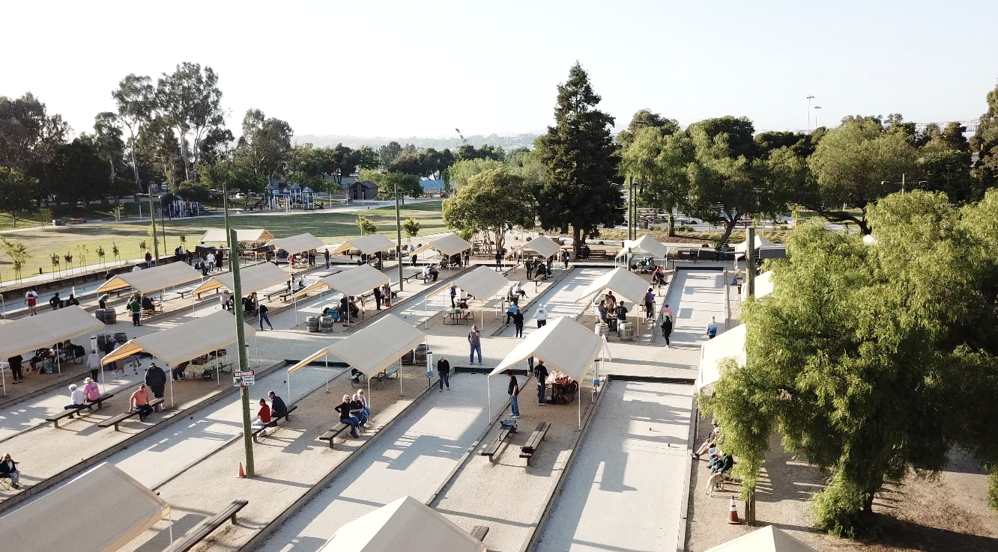
MARTINEZ BOCCE FEDERATION PRESENTS
COMMEMORATIVE CUP BOCCE TOURNAMENT
September 17 and 18, 2022
Format will be for 32 maximum teams (only 4 openings left)
Deadline August 15th.
First four entries and fees received
$100 per person ● 4-person team minimum, maximum 5 ● 5th person $75
Martinez Federation open rules, Dead Backboard, Only MBF bocce balls will be used
Continental Breakfast and Lunch each day for players only
1st day Round-robin tournament play 2nd day guarantee 2- games in elimination round
CASH PRIZES
1ST $3,000 2ND $2,000 3RD $1,000 4TH $600 5TH thru 8th $200
Single elimination 2nd chance play
1st $500 2nd $400 3rd $300 4th $200
COMPLETE ENTRY FORM BELOW AND RETURN NO LATER THAN August 15th, 2022

Your Name: __________________________________ Team Name: _____________________________________________________
Capo Name: _______________________________________ Capo email address: ________________________________________
Capo Address: _____________________________________ Number of Players on your team: ___________
Cash or check amount enclosed: $_____________________
Mail to: Martha Crosley, 5 Shale Circle, CA 94509
CONTACT: Martha Crosley Cell: 925-499-1160 Email: mtcrosley@outlook.com

