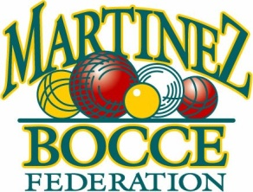
Attention Returning Teams: Please refer to the current details listed on the MBF website and/or any
documents or forms sent either by EMAIL or USPS showing the day & time for submission of this roster.
New Teams: 9am w/Check and Roster Sun.February 13th 2022 @ Bocce Courts – First come, First served.
One completed roster and check is required for each team playing in OPEN, VOLO or SENIOR League.
ROSTERS/CHECKS WILL NOT BE ACCEPTED BY MAIL. Venue: MBF Club House at the Bocce courts.
2022 ROSTER

This row for Federation  use only | Roster # | Date | Check | Cash

Team Name: | New Team? Yes No

 | Player Name |  |  | Address |  |  |  |  | City | Zip |  | Phone | E-Mail
1 | Capo
2 | Vice Capo
3
4
5
6
7
8
9
10
11 | Alternate
12 | Alternate
Entry Fee (check one): |  | VOLO ($250, Monday Only) |  |  |  |  |  | Open ($400) |  |  | Senior ($200)
Open League Only: A B B B |  |  | C |  | D | E | Night of Play (check one) : Mon Tues Wed Thurs Fri Sun
Important Reminders: All rosters must have complete addresses and telephone numbers for each member of the team, including Alternates. INCOMPLETE FORMS WILL NOT BE ACCEPTED. Alternates will not get an award. 30% rule applies to playoff eligibility and awards.
As Capo, I hereby swear that each team member, before their first game of play, will read and abide by the RULES of the Martinez Bocce Federation. ALL CAPO’S WILL BE HELD RESPONSIBLE FOR THIS REQUIREMENT AND THE ACTIONS OF THEIR TEAM MEMBERS.
Name (Print): Signature: Date:

